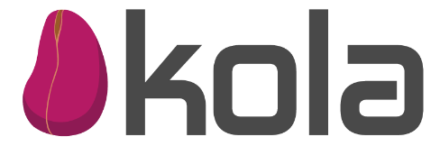

MINUTES OF MEETING OF KOLA’s GOVERNANCE FOR KOLA DIGITAL FINANCE

Opening:
Minutes of meeting of GOVERNANCE for KOLA DIGITAL FINANCE duly called and held on December 12, 2023, at Mr. Crayton Office Newport St, commencing at 2:00pm.

Were Present:
Joseph Crayton
Yves Mbondji
Joanna Washington-Davis
Monique Yhap-Scott
Valecia Wahyon-Diggs
Glory Harmon
George Crayton
Niels Peter

It was discussed:
- Soft Lauch is on its way. The apps are ready and now Kola is waiting on the Apps Approval for both Google and Apple Stores
- Operations and Marketing are prepared for onboarding of both agents and merchants once the Apps are available on Google. Based on previous discussions, soft launch will start with Google until Apple’s approval completes
- January 31, 2024, has been chosen as the official Kola Live (Public)
- Tech team working on testing environment and a few other things
It was Agreed the following:
- Everyone agreed about the wait for Google and Apple Stores
- Tech will continue to complete Production (DNS server issue) and testing environment setup
- Marketing and Operations will complete any remaining items (i.e. merchant contracts, agents training, additional marketing content) while Kola wait on approvals

